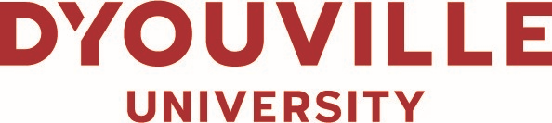
CONFLICT OF INTEREST DECLARATION
D’YOUVILLE UNIVERSITY
INSTITUTIONAL REVIEW BOARD MEMBERS

A conflict of interest exists when an officially appointed IRB Member of D’Youville University determines that a significant financial interest of an investigator or a significant external investigator could directly and significantly affect the design or reporting of research. A conflict of interest and the conduct of externally and selected internally supported research may take several forms, but typically arises when the IRB Member within D’Youville University is, or may be, in a position to influence the activity of IRB decisions in ways that could lead to personal gain.

IRB Board Members are responsible for making known any potential or perceived conflict of interest concerning protocols reviewed by the IRB. This would include the IRB member’s service in any of the following categories with respect to the study in question:
- Principal Investigator,
- Co-Principal Investigator,
- Investigator receiving funding from the study, as listed in the study budget,
- In a supervisory role over the PI of the study, and
- Family members of the PI.

The Food and Drug Administration (FDA), 21 CFR 56.107(e) and 45 CFR 46.107(e) state that:
* No IRB may have a member participate in the IRB’s initial or continuing review of any project in which the member has a conflicting interest, except to provide the IRB with requested information,
*Accordingly, an IRB should develop a COI policy that covers a member’s financial, personal, and professional conflicts of interest,
* A financial COI might exist if the investigator has a financial interest in either the sponsor of the research or the test article. Financial interests also arise from owning stock in the sponsor’s company, having a consulting relationship with the sponsor, or being a spokesperson of the sponsor. The IRB should consider what level of financial interest would create a COI requiring the IRB member to be removed from IRB deliberations and voting,
* A personal COI arises when the IRB member is asked to review research being sponsored and/or conducted by a close friend or relative, and
* A COI might exist when an IRB Member is asked to review research being sponsored and/or conducted by a supervisor, such as a department chairperson.

Board Members are required to make known any conflict of interest prior to the beginning of the Board’s discussion of the protocol under review. They must leave the meeting room prior to the Board’s deliberation and vote.

I, , as an officially appointed Institutional Review Board Member of D’Youville University, have read and understand the D’Youville University Policy and Procedure on Conflict of Interest for “IRB Membership.”

I, , agree to make known any conflict of interest prior to the beginning of the Board’s discussion of the protocol under review and will leave the meeting room prior to the Board’s deliberation and vote.

Corporate Compliance Reviewer Signature
Date: Click to select a date.

